# **St Paul’s**

# **Presbyterian Church**

------------------------------

## “Where Faith in

## Jesus Christ Flourishes



**“Promise and Pain”**

**Romans 8: 18-27**

**Sunday 1st September**

What’s On

# St Paul’s Congregational Survey

Thank you to all of those who participated in the survey. The data of this will be disbursed in due course.

# **Cameron Munro -** DIRECTOR OF TRAINING | LEAD CONSULTANT

We welcome Cameron to St Paul’s. Since January 2022, Cameron has been a Lead Consultant (and Director of Training) with City to City Australia. Over this period, he has worked with churches from various denominational backgrounds in both Australia and New Zealand. He has also been involved in the ongoing development of the tools and interventions used in the Revitalisation program.

# Upcoming AGM

As part of our preparation for the upcoming AGM, you all have receive the **financial annual report and proposed budget for the 2024/2025** year for your review. We will be voting on the budget’s approval at the AGM meeting at the end of September. If you have **any questions or considerations** relating to these reports, please refer them to **Session, Vanya Wallis** per email at [vanya.wallis@gmail.com](mailto:vanya.wallis@gmail.com) **by Sunday 15 September** to allow for proper response.

# India

Ethan and Miriam will be having two **fundraiser events this month**. The money raised will be going towards their trip to India and you support would be greatly appreciated. The dates for these are a **carwash on Saturday 14th from 8am - noon** and a **garage sale and car wash on 21st September from 8am - noon**. If anyone has **donations towards the garage sale**, please talk with Miriam or Ethan.

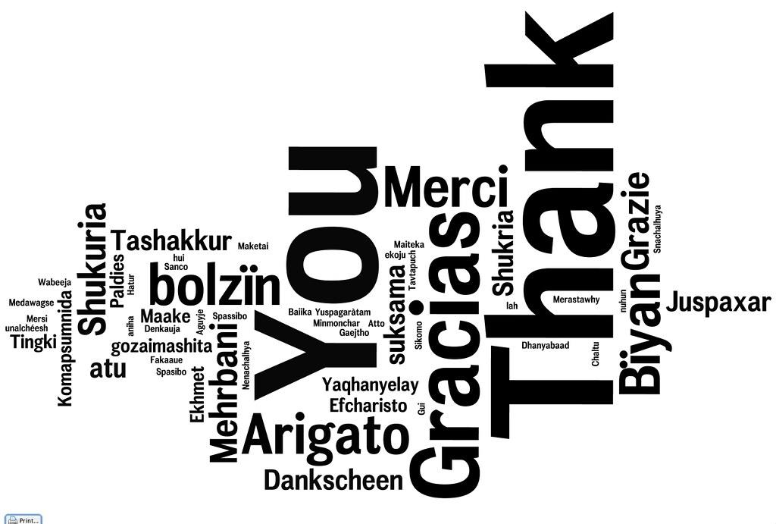

# Roster

Thank you to everyone who has volunteered their time during the last stretch. Your precious giving is very much appreciated.

News and Events

Ethics & Risk Management

Here are the dates for our online half-day Ethics & Risk Management Workshops for 2024.

Tues 15 October; 9-12:30

Tues 19 November, 9-12:30

Places can be booked by emailing **kate@presbyterian.org.nz**



**CAMERON MUNRO - DIRECTOR OF TRAINING | LEAD CONSULTANT**

Cameron has called the beautiful city of Adelaide home since 2007. Before that, he lived and worked in the Greater Sydney region.

After school, Cameron trained and worked as a Physiotherapist in major public hospitals in central and western Sydney.

He entered Moore Theological College in 1997 as a Candidate for Ordination in the Anglican Church and was ordained by the Archbishop of Sydney as deacon in 2001 and as priest in 2002.

Cameron has a long history of pastoral leadership within the Anglican Church, in both the Sydney (2001-2007) and Adelaide (2007-2021) dioceses. He has served as pastor in churches of different sizes and complexity and in varied socio-economic environments.

From 2007-2021, Cameron worked as a Senior Pastor within the Trinity Network of Churches. During that time he was part of the senior leadership team that oversaw the Network’s growth from three to fourteen churches, including great-granddaughter plants. He served on the Trinity Network Board from 2015 to 2017.

Cameron has a track record of establishing newly started ministries. He was called to churches three times as their second pastor after planting or repotting. He is gifted at establishing ministry systems, reforming and refining ministry practices, and building on the foundation that was laid by the initial pastor to set the church up for ongoing fruitfulness. On two occasions, Cameron has been involved in preparing churches to send staff and significant core teams to plant new churches and leading the rebuilding phase after the planting team had been sent. Cameron has also successfully led congregations through times of significant change.

Cameron holds a Bachelor of Divinity (Hons2a), Diploma of Ministry, and Master of Arts (Theology) with Merit through Moore Theological College. He also was awarded a Doctor of Ministry from Fuller Seminary. His thesis was entitled, “Enabling Trinity Hills to Address the Challenges of Contemporary Australian Culture in Discipling Children and Youth”. He also holds a Bachelor of Applied Science (Physiotherapy) from Sydney University.

Since January 2022, he has been a Lead Consultant (and Director of Training) with City to City Australia. Over this period, he has worked with churches from various denominational backgrounds in both Australia and New Zealand. He has also been involved in the ongoing development of the tools and interventions used in the Revitalisation program.

Cameron has also served as an Adjunct Lecturer at Bible College South Australia since 2016, teaching subjects in Leadership, Mission, Worship, and Gospel Theology.

On a personal front, Cameron married his wife, Karen, in 1993, and together they have four adult children. Cameron and Karen are members of St Bart’s Anglican Church, Norwood. 



# Baptism Classes

Have you considered being water baptised?

Baptism is an important part of what it means to follow Jesus.

If you are interested, please talk to Ken Harray or Vanya Wallis.

# Prayer

We believe in a God, who hears and answers prayer.

Tuesdays 9:30am is our St Paul’s Church Prayer Meeting. 

A confidential “prayer (tea) pot” is located in the foyer if you would like prayer. Prayer is always available after our Sunday worship.

# CHURCH GIVING AND BANK ACCOUNT DETAILS

If you wish to set up an automatic payment or make a donation to St Paul’s, please use the following details:

**Katikati Presbyterian Church, 02-0340-0013449-00**

Alternatively, you can join the envelope system, please see the office for more details.

**As people are using internet banking, we do not take up an offering during the service. If you would like to give, please use the wooden box in the foyer. Thank you.**

Regular Dates

**SMALL GROUPS**

**Monday Afternoon**

From 1.30pm to 3.00pm at 34 Longmynd Drive, Katikati. For more information, please talk to Alison 027 662 3246 or Paul Parish on 027 423 0836.

**Bible Study at the Foris Home Group**

MONDAY evenings at 7:00 PM. The Foris home 44 Ballantyne Way at the Fairview Estate, ph. 07-549-3346. **New series**: “**The Armour of God**” by Bill Search. **Nine sessions** on how to stand strong during the challenges of life by properly putting on the Armour of God.



**Mainly Music**

Mainly Music Friday mornings at 9:30am. For pre-school aged children and their parents or caregivers. **(except school and public holidays)**. A donation of $3.

**“His Youth”**

His Youth Group **Friday, 7 – 9** pm (except school and public holidays). For Year 8 and up. See Miriam for more details.



**Men’s Prayer Breakfast**

First Saturday of every month at St Paul’s lounge. All are welcome. For more information talk with **Paul Parish 027 432 0836**

**CAMEO**

On the 3rd Wednesday of every month. CAMEO is a group of women passionate about mission. All are welcome. For more information please talk with **Jean 021 262 4985 or Marjorie 07 549 5722**

**Rest Home Visits**

Every third Sunday afternoon. For more information, please talk with **John Ormsby**

**022 631 6501**

**CONTACTS**

**Interim Moderator** Rev Ken Harray **phone** 549 2286 **email** [kenharray@gmail.com](mailto:kenharray@gmail.com)

**SESSION CLERK** Vanya Wallis **phone** 0212301741 **email** [vanya.wallis@gmail.com](mailto:vanya.wallis@gmail.com)

**TREASURER** Dirk Verbeek **emai**l [treasurer@stpaulskatikati.org.nz](mailto:treasurer@stpaulskatikati.org.nz)

**CHURCH OFFICE phone** 549 0098 Open Tuesdays-Wednesdays 1:30-4:30pm,

Thursdays 1-5pm

**Office Administrator**: Karen Verbeek Tuesdays-Wednesdays 1:30-5pm,

Thursdays 12:30-5pm, Friday 7-9pm (subject to change. Please ring first)

**CHURCH BOOKINGS AND NOTICES FOR NEWSLINE**

**Email:** [admin@stpaulskatikati.org.nz](mailto:admin@stpaulskatikati.org.nz) Newsline deadline Thursdays 3pm

**Youth Pastors Ethan and Miriam email** [hisyouthkatikati@gmail.com](mailto:hisyouthkatikati@gmail.com)

**PASTORAL NEEDS CONTACT:** Christine Rickard **PH** 0273211797

**Email:** [christine.rickard49@gmail.com](mailto:christine.rickard49@gmail.com)

For an audio file of Sunday’s message follow this link:

<https://www.stpaulskatikati.org.nz/copy-of-publications>.

Also, check out our Facebook page: St Paul’s Presbyterian Church, Katikati

be with you